**Shre e Swa mina ra ya n College of Computer Science**



**Sardarnagar, Bhavnagar.**

**(Affiliated to M. K. Bhavnagar Univers ity)**

|  |  |
| --- | --- |
| **Progress Report Number:** | 2 |
| **Project Title** | Master Budget |
| **Project Guide** | Mr. Nirav Shah |

|  |  |
| --- | --- |
| **Submission Date** |  |
| **Signature of Students** |  |
|  |
|  |
| **Signature of Guide** |  |

|  |  |
| --- | --- |
| **Roll No.** | **Name of Student** |
| 0122058 | Mr. Vinay Dodiya |
|  |  |
|  |  |

1. **Data Flow Diagram**

* A **Data Flow Diagram (DFD)** is a visual representation of how data moves through a system. It is used to model the flow of data between processes, data stores, and external entities. DFDs are hierarchical, meaning they can be broken down into levels of detail, starting from a high-level overview (Context Diagram) to more detailed levels (Level 1, Level 2, etc.).
  1. **Components of DFD**

**1.1.1 External Entity**

|  |  |  |
| --- | --- | --- |
| Symbols | Author | |
| Yourdon & Peter Coad | Gane & Sarson |
| External Entity | External Entity | External Entity |

**Description:**

* This External Entity is use for write a user name, customer name, etc.
  + 1. **Process**

|  |  |  |
| --- | --- | --- |
| Symbols | Author | |
| Yourdon & Peter Coad | Gane & Sarson |
| Process |  | Process |

**Description:**

* This Process is use for write a Validation, Verification, etc.
  + 1. **Database**

|  |  |  |
| --- | --- | --- |
| Symbols | Author | |
| Yourdon & Peter Coad | Gane & Sarson |
| Database | Data Store | Data Store |

**Description:**

* The Database should be / must be 1 side or 2 side open otherwise that are not called database.
* Database also called Data Store**.**

**1.1.4 Flow of Data**

|  |  |  |
| --- | --- | --- |
| Symbols | Author | |
| Yourdon & Peter Coad | Gane & Sarson |
| Flow of Process |  |  |

**Description:**

* This is a flow of process symbol; it uses to describe the flow of process that where to start & where to end.
* The flow of process symbol also known by Structure Pointer & Data Flow.
  1. **DATA FLOW DIAGRAM**

**1.2.1 0 Level DFD for Master Budget System**

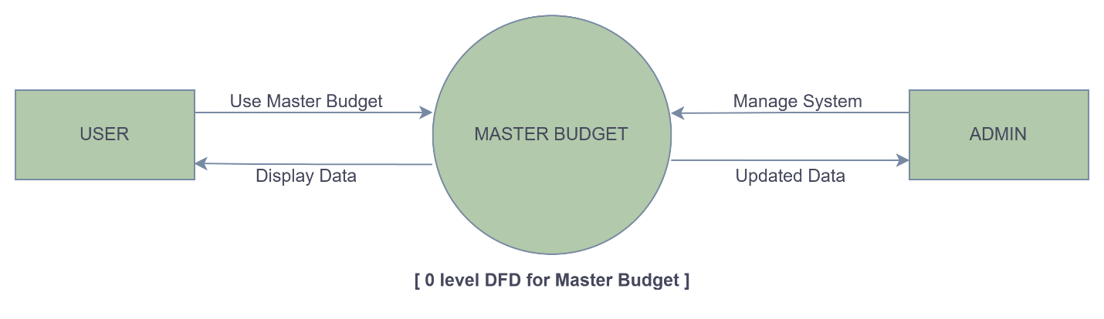

* + 1. **1st Level DFD for User**

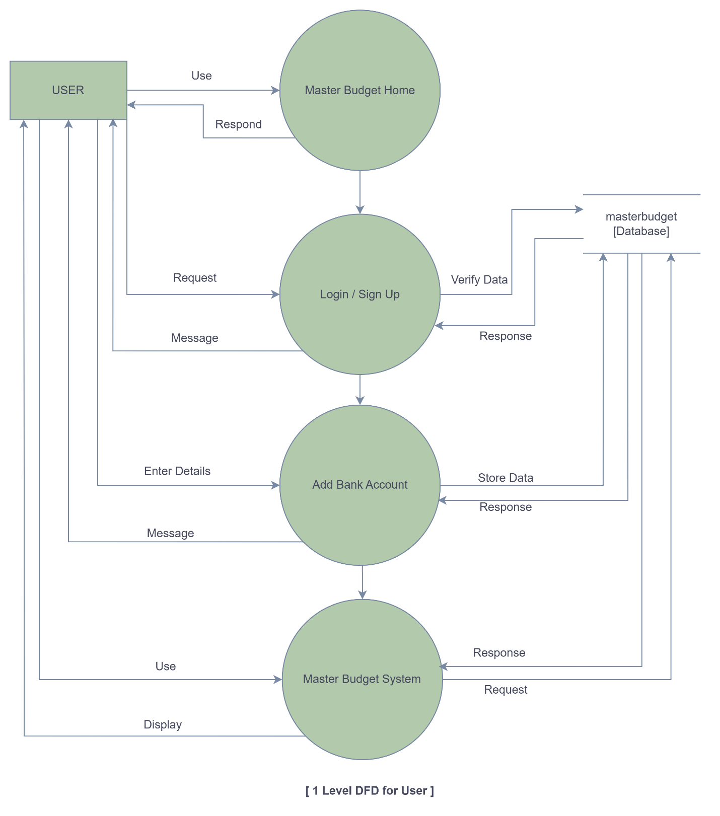

* + - 1. **2dn Level DFD for User**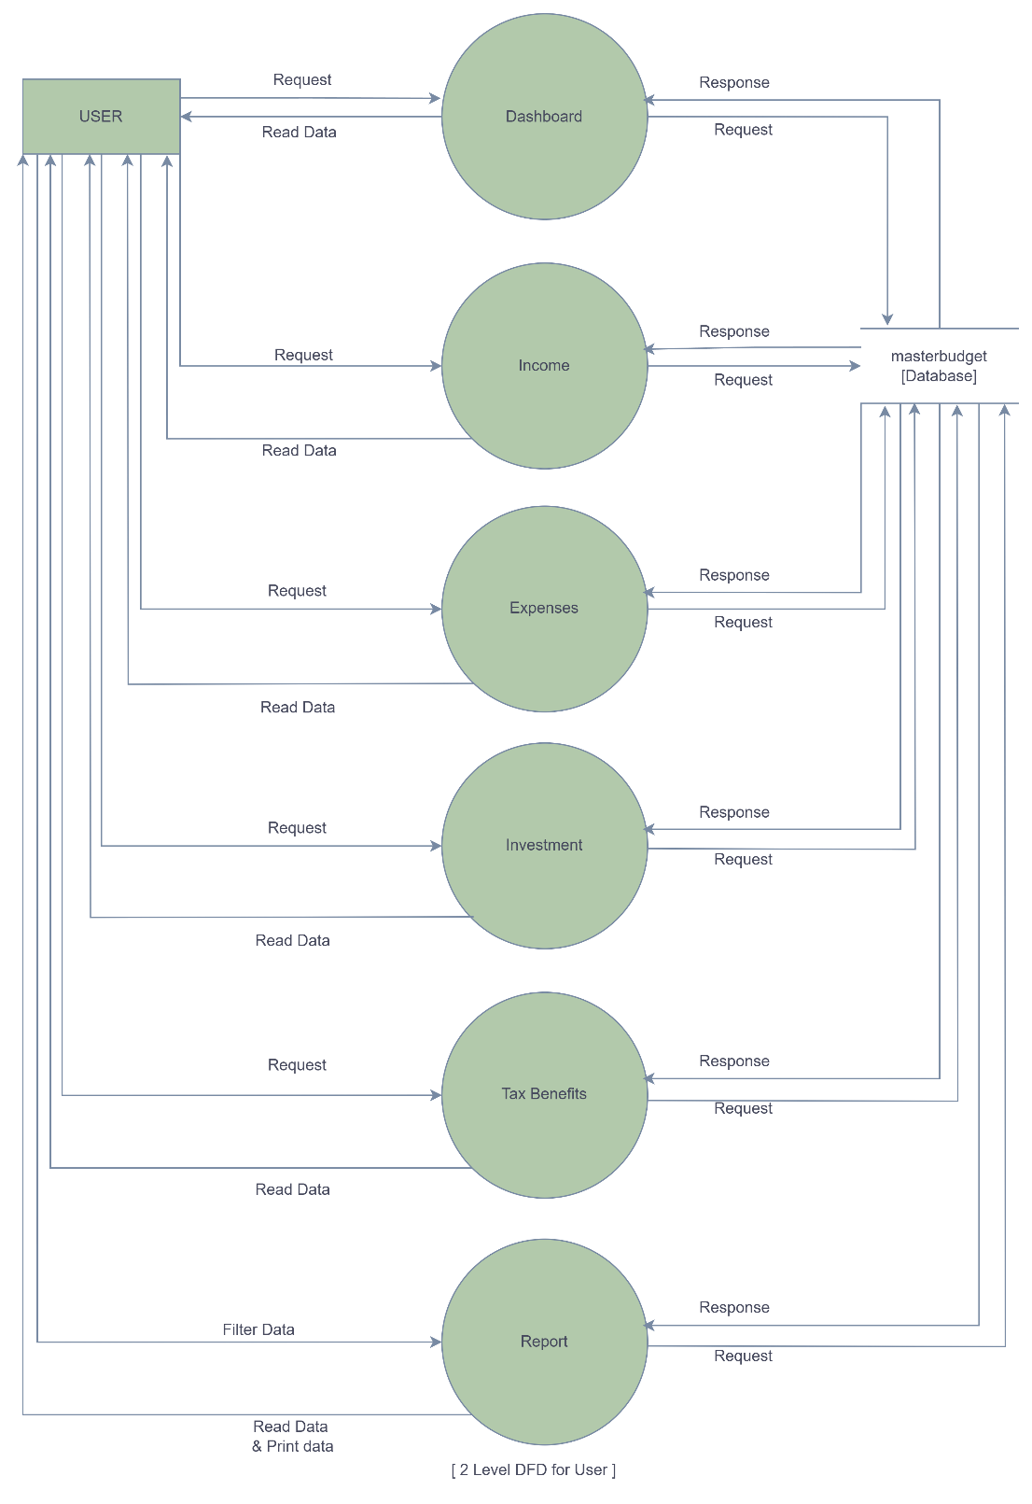
      2. **3rd Level DFD for User in Income**

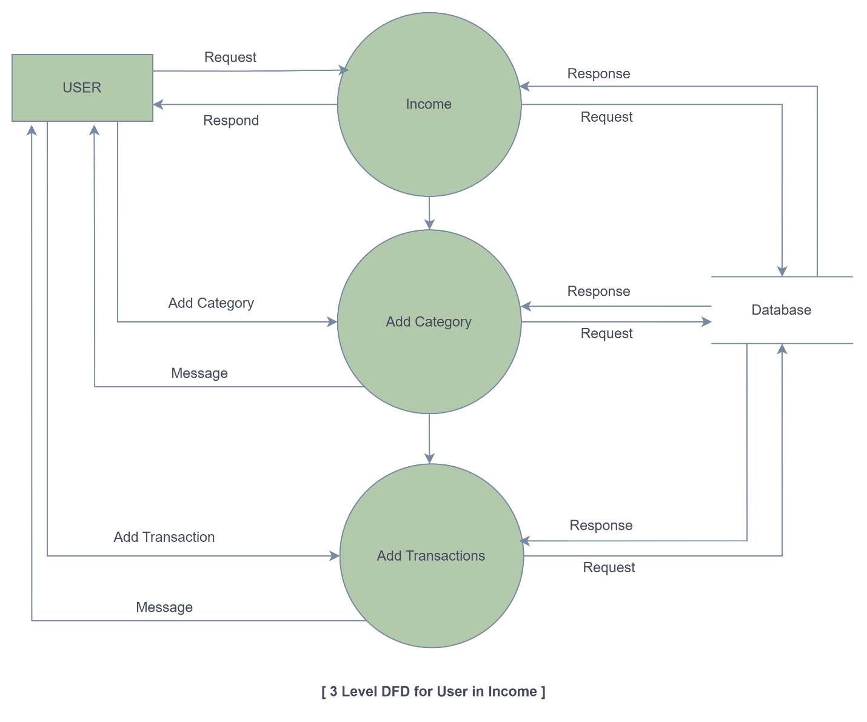

* + - 1. **3rd Level DFD for User in Expenses**

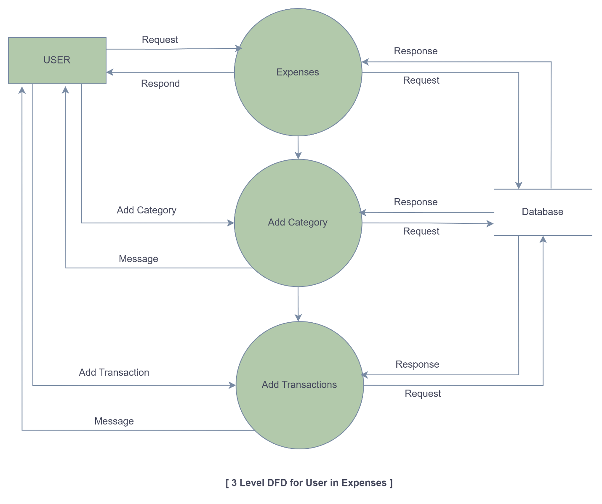

* + 1. **1st Level DFD for ADMIN**

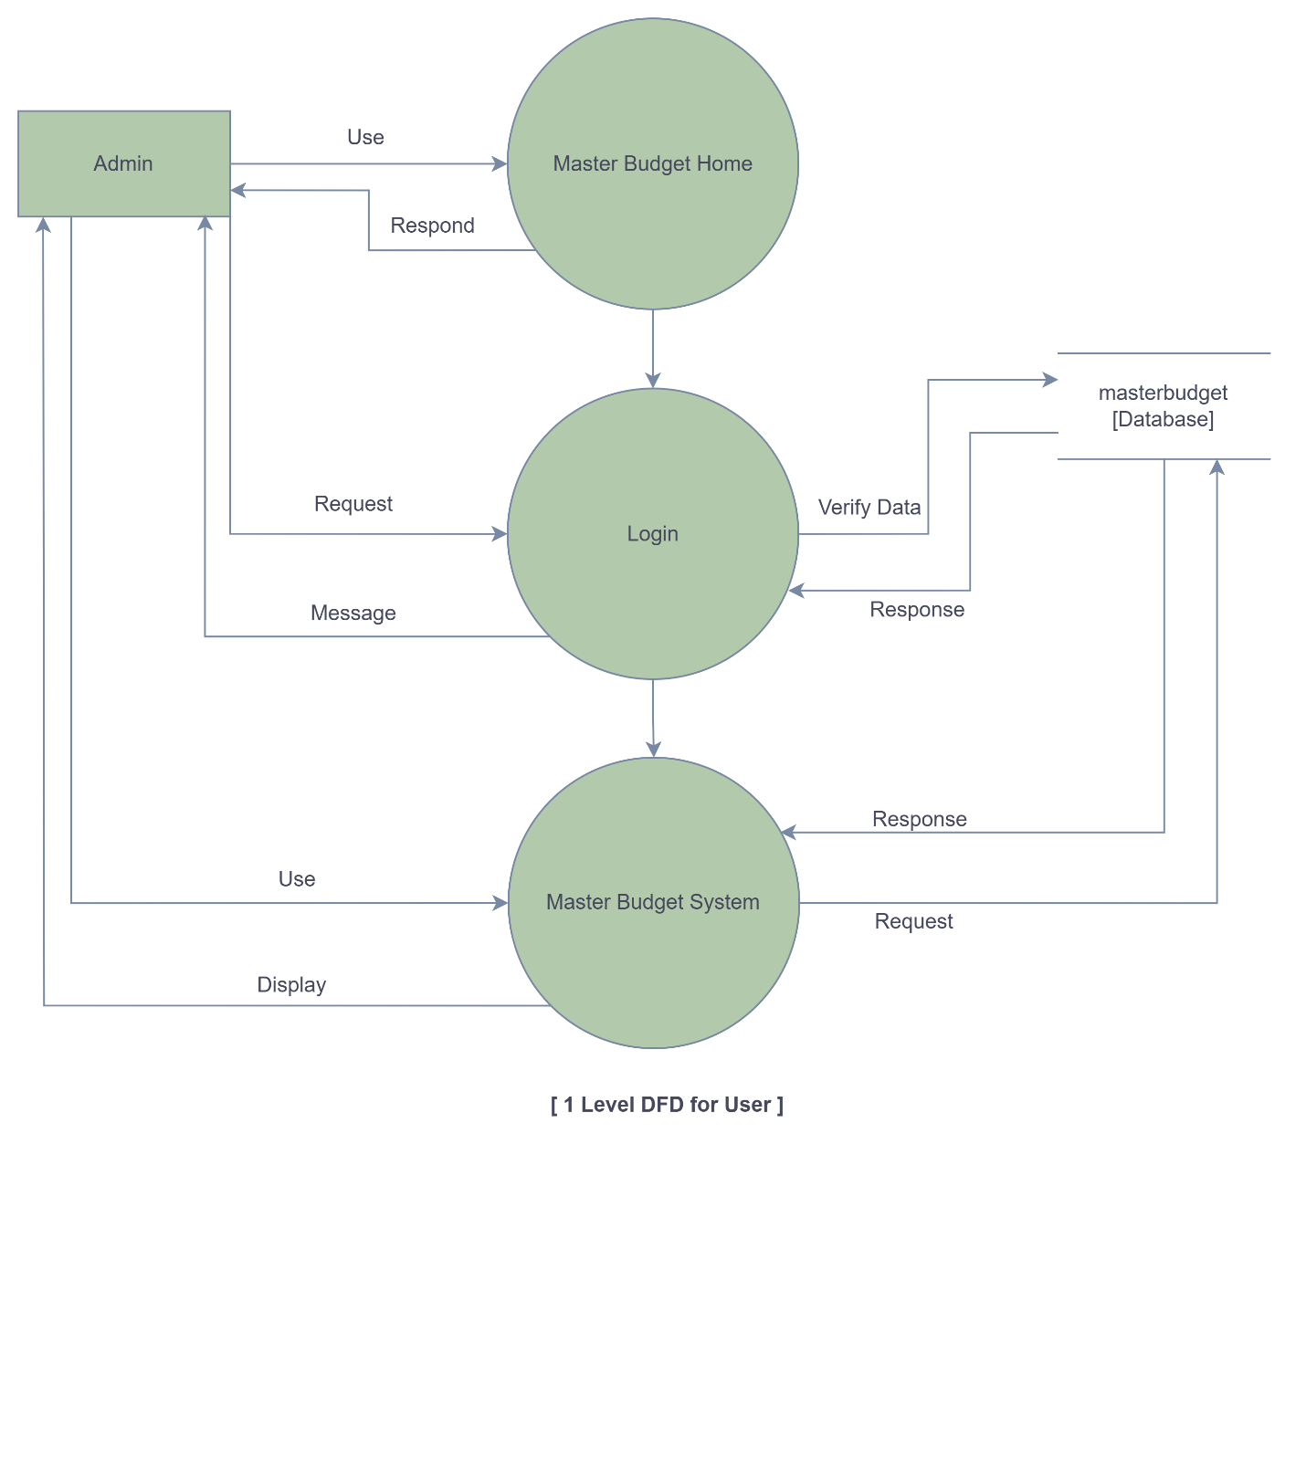

* + 1. **2nd Level DFD for ADMIN**

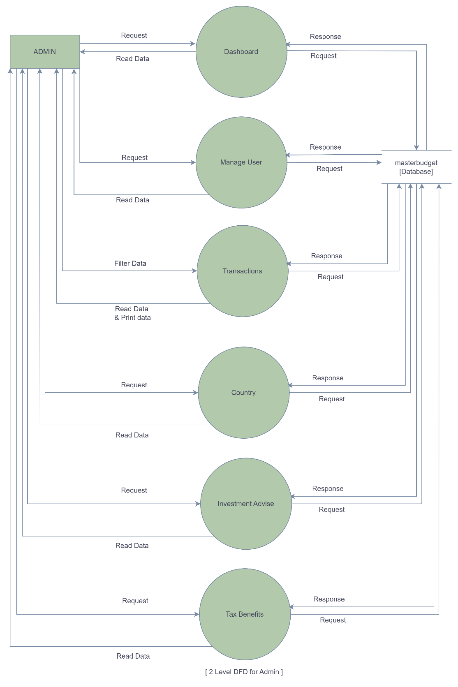

1. **SCREEN LAYOUT**
   1. **Dashboard Page** 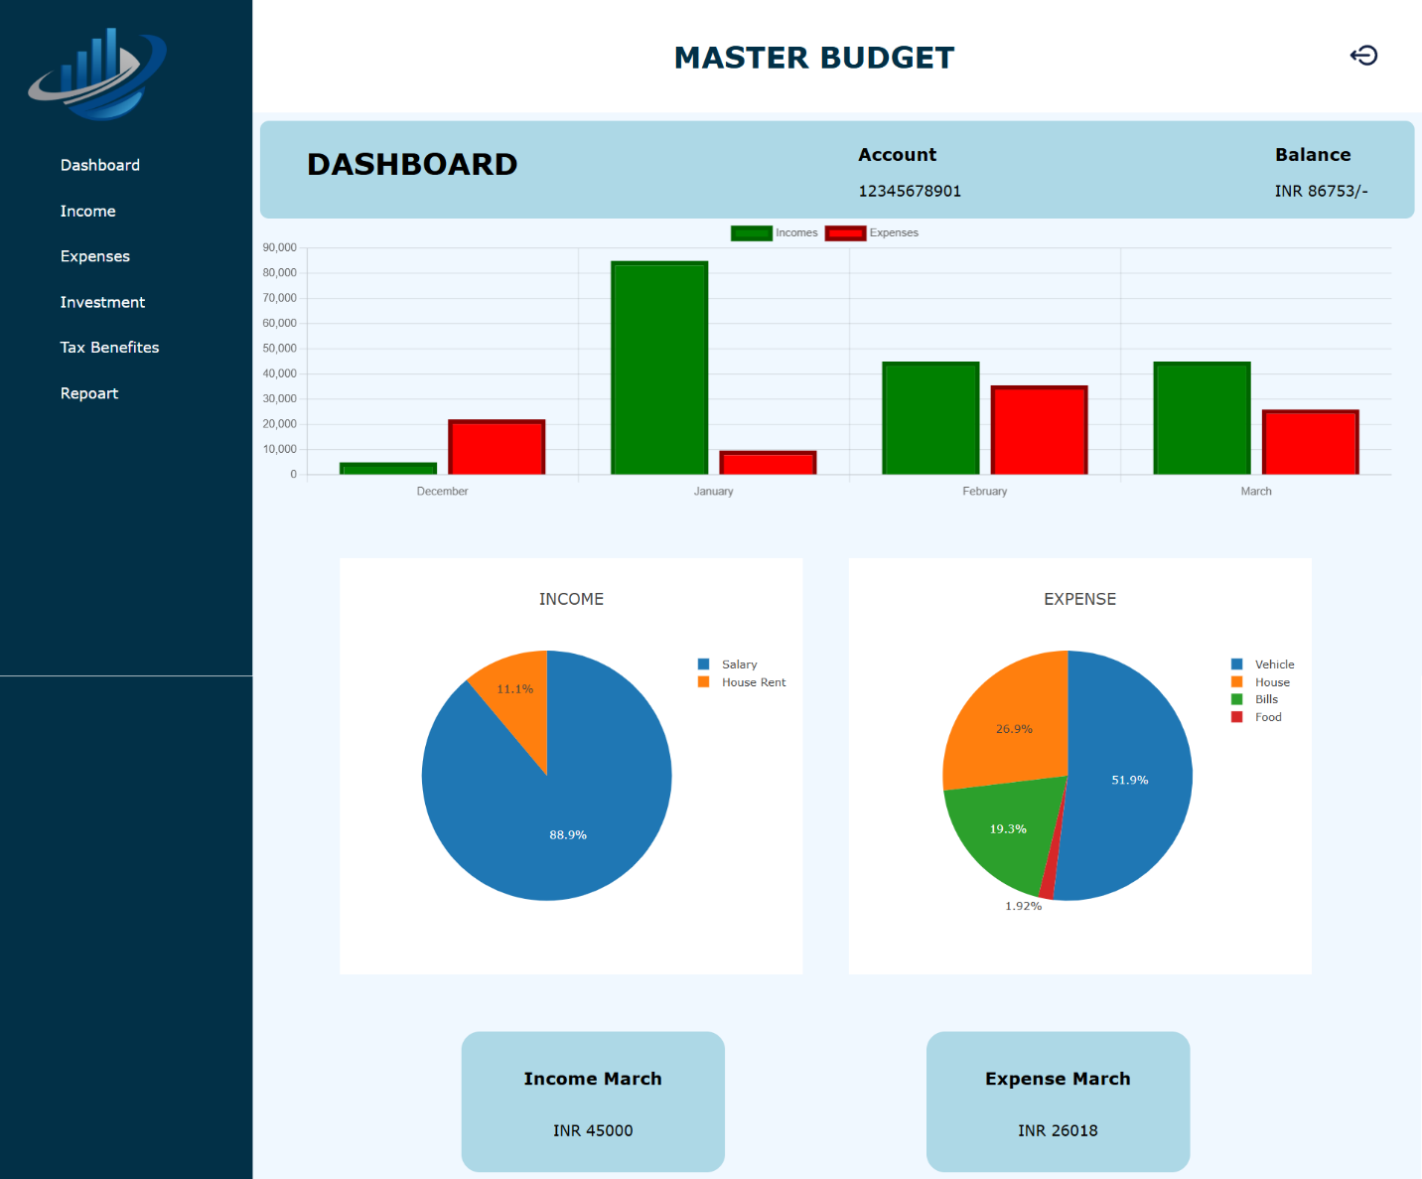
   2. **Income Page**

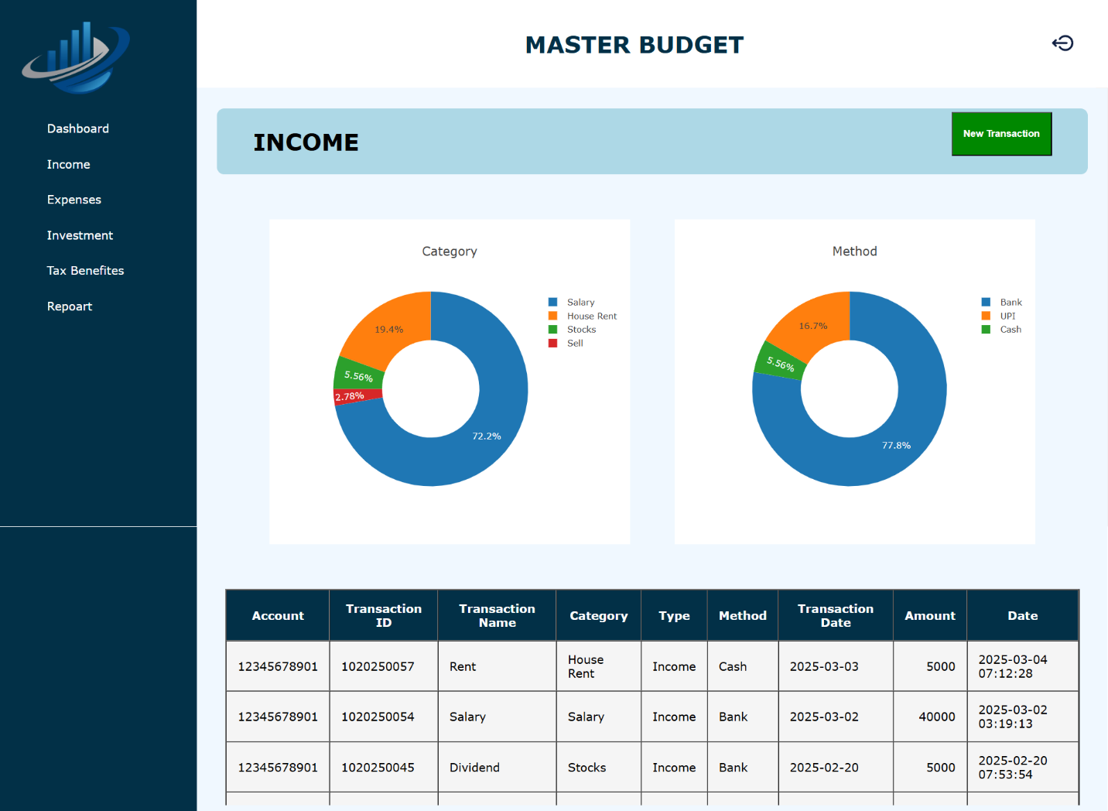

* 1. **Expenses Page**

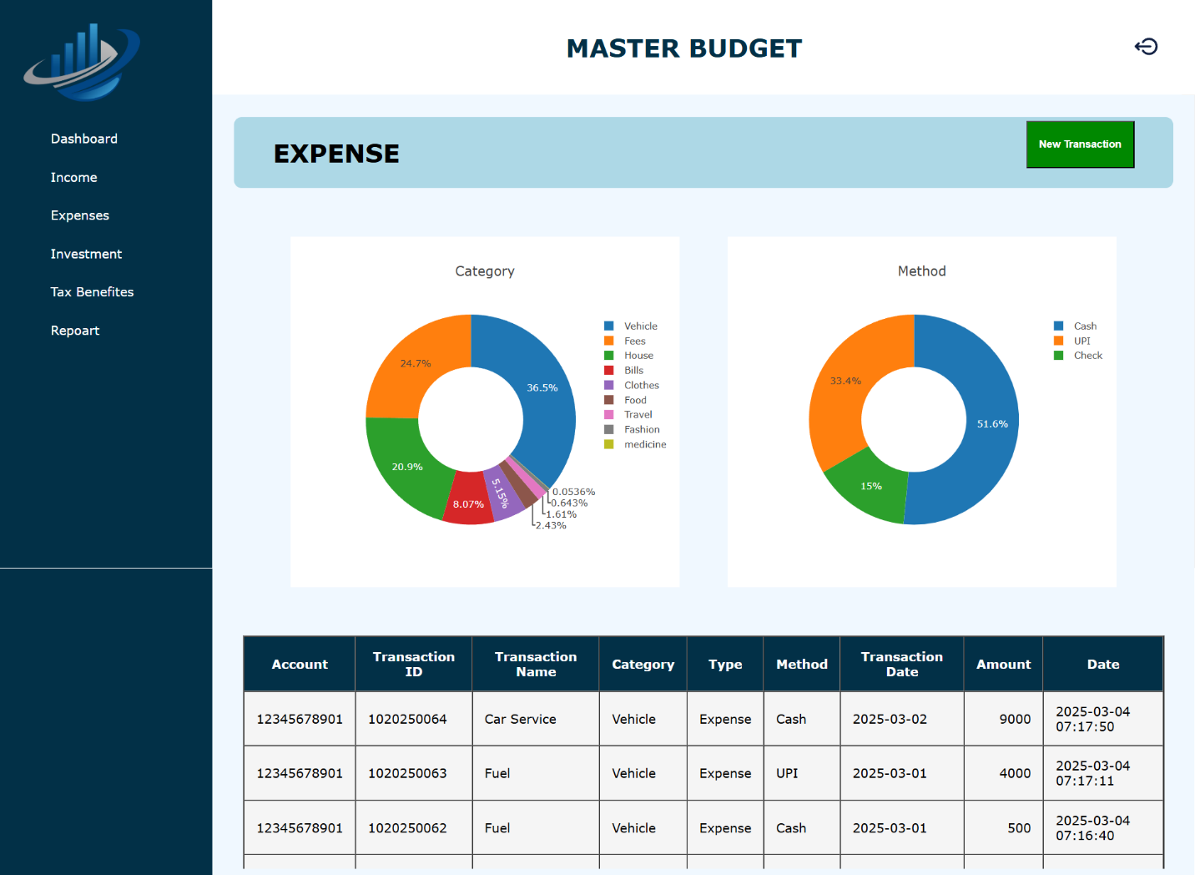

* 1. **Investment Page**

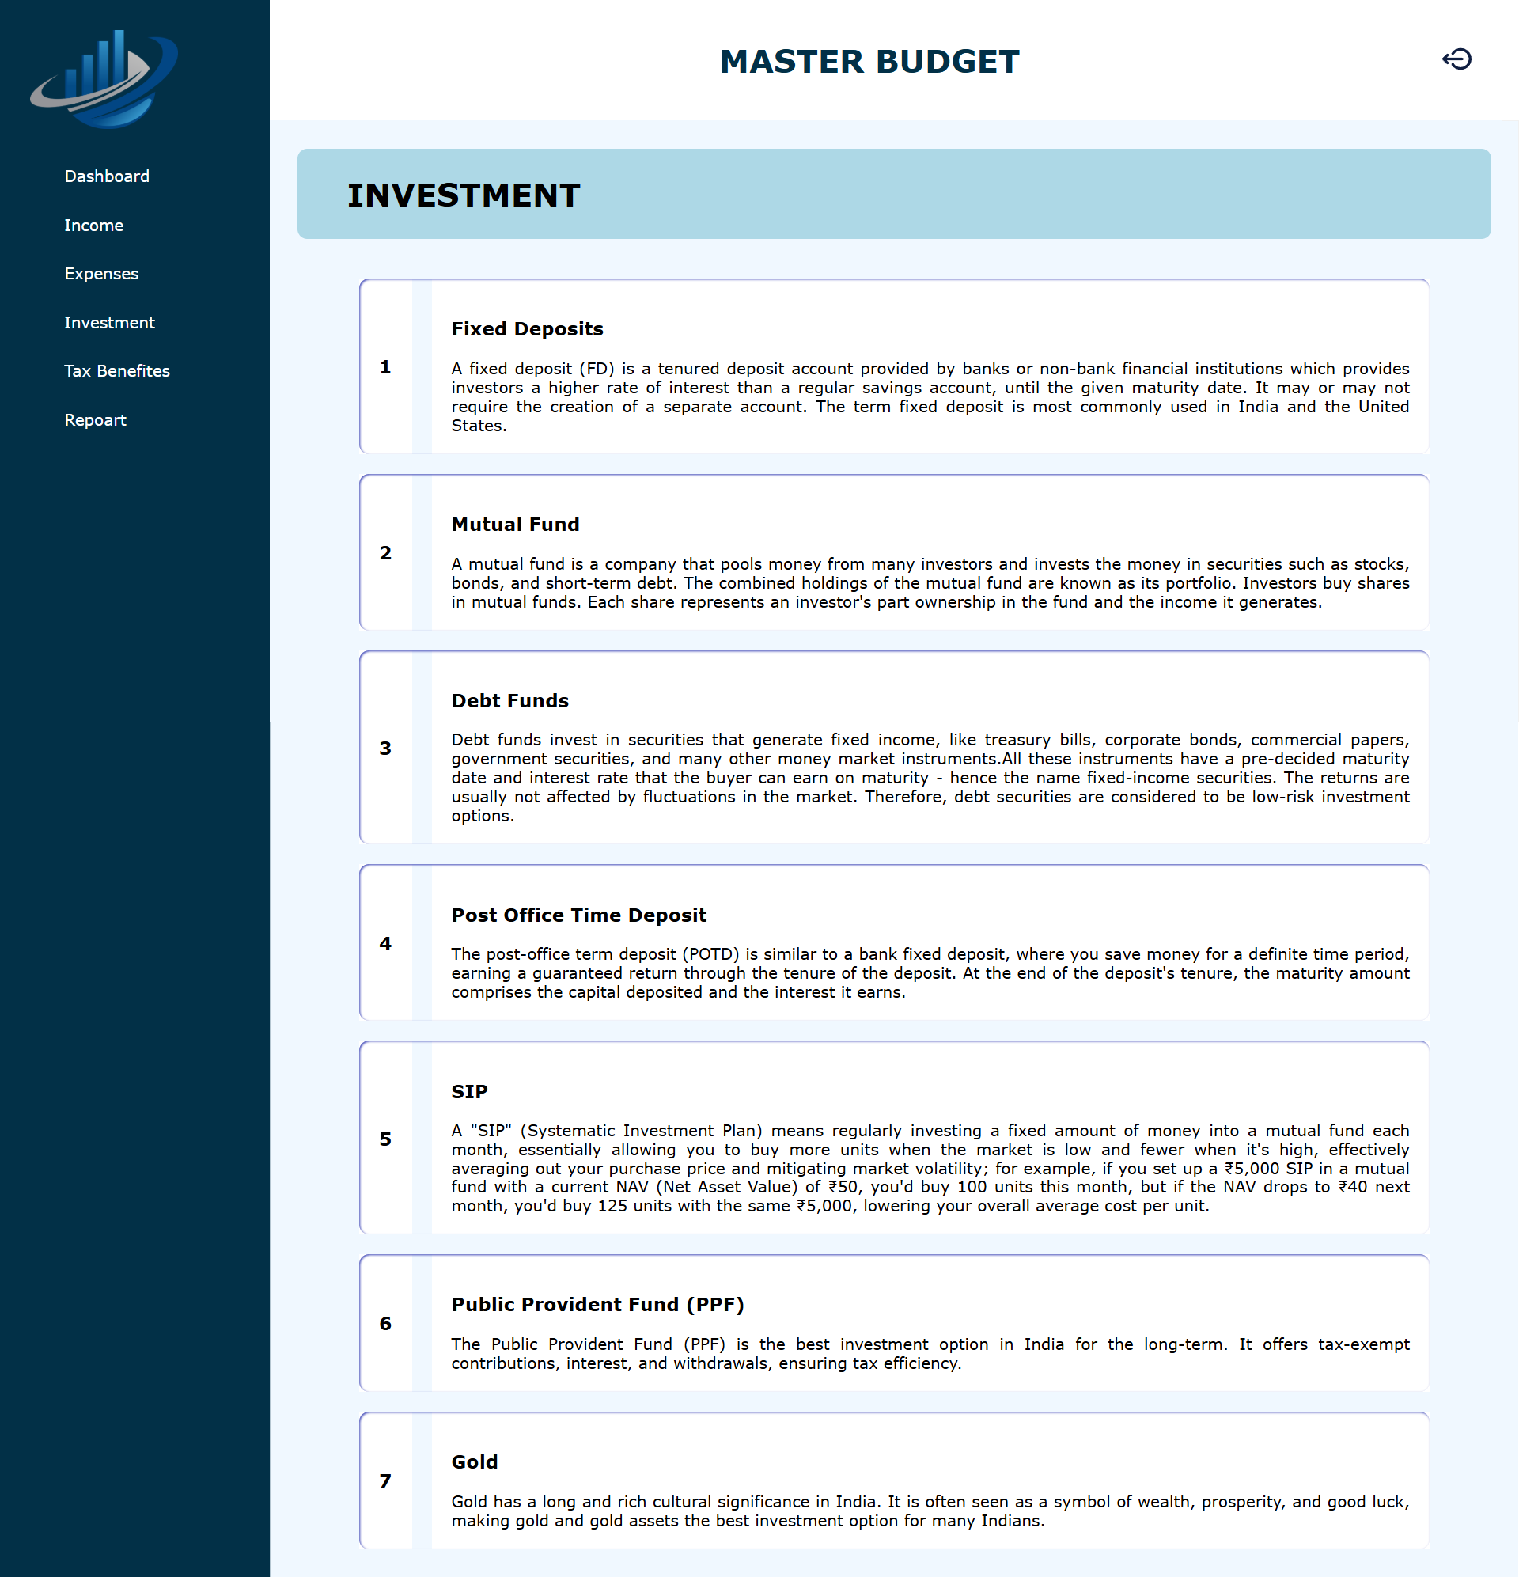

* 1. **Report Page**

